Spring core and Maven Exercises  
  
I have made a single program implementing all the mandatory and additional features and here I m describing what I did in those exercises

**Exercise 1: Configuring a Basic Spring Application**

Set up a basic Spring project with XML configuration.

**What I did:**

Created a Maven project named LibraryManagement.

Added Spring core dependencies (spring-context) to pom.xml.

Created applicationContext.xml in src/main/resources.

Defined beans for:

BookService

BookRepository

Created com.cognizant.LibraryManagement.service.BookService and com.cognizant.LibraryManagement.repository.BookRepository.

Created LibraryManagementApplication.java to:

Load the Spring context using ClassPathXmlApplicationContext

Retrieve and use the BookService bean.

**Exercise 2: Implementing Dependency Injection**

Connect BookService and BookRepository using Spring’s IoC container.

**What I did:**

Modified applicationContext.xml to wire bookRepository into bookService using:

Constructor injection with <constructor-arg>

Setter injection with <property>

Updated BookService.java to include:

A constructor accepting BookRepository

A setter method for BookRepository

Verified injection by calling a method from BookService in LibraryManagementApplication.

**Exercise 4: Creating and Configuring a Maven Project**

Setup project and dependencies.

**What I did:**

Created Maven project LibraryManagement.

Added dependencies in pom.xml:

spring-context

spring-aop

spring-webmvc

Configured Maven Compiler Plugin

**Exercise 5: Configuring the Spring IoC Container**

Central configuration of beans and dependencies.

**What I did:**

Created applicationContext.xml with <beans> to define and wire beans.

Verified bean setup using Spring context and logs.

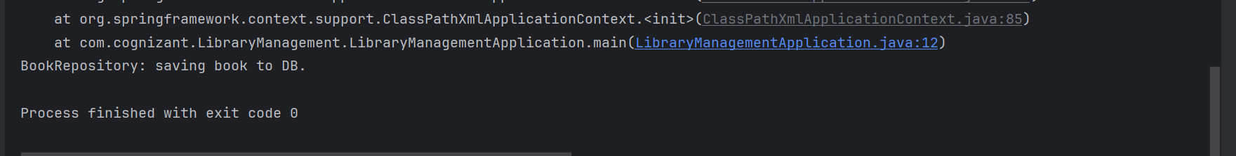

**Exercise 6: Configuring Beans with Annotations**

Replace XML bean definitions with annotation-based configuration.

**What I did:**

Annotated:

BookService with @Service

BookRepository with @Repository

Enabled component scanning in applicationContext.xml:

Removed manual <bean> declarations from the XML.

Verified that Spring autowired dependencies correctly using annotation-based configuration.

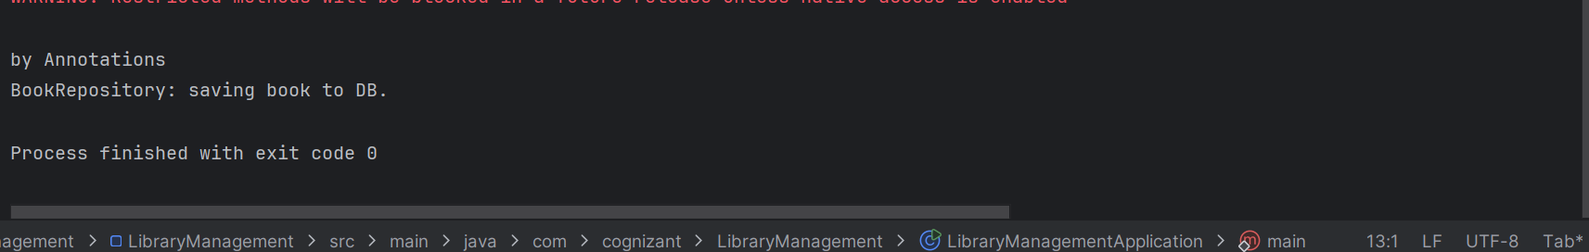

**Exercise 7: Constructor and Setter Injection**

Use both constructor and setter injection in BookService.

**What I did:**

Configured both constructor and setter injection:

In XML (before switching to annotations).

In Java class with @Autowired on constructor and setter.

Confirmed both approaches work and dependencies are injected correctly